User 3 —
GPS Tracking and Electronic Fence
User Story
As a pet owner, I want to set a safe area for my pet and receive an alert if it leaves that area, so that I can respond before the pet is completely lost.



User Activity
·The dog was asked to wear the GPS tracker.
·The user was asked to evaluate the dog’s comfort level based on its behaviour.
·The user was asked to walk the dog within a 1000-metre range.
·We observed whether the GPS location was accurate and whether the signal remained stable.
·The user was asked to give a rating for the GPS accuracy and signal quality.
·The user was asked whether they had any deeper or potential needs related to GPS Tracking.
User Validation Criteria
Metric | Target / Standard
GPS comfort observation | The dog can wear the GPS tracker without obvious discomfort during the test.
GPS accuracy and signal quality | User gives feedback on whether the GPS location is accurate and whether the signal remains stable.
Proactive safety need | User can explain whether a safe-zone alert would be useful.
Usefulness rating | User gives the improved GPS safety function a usefulness score of at least 4 out of 5.
User Feedback
Before optimisation, User 3 understood that GPS Tracking could show the pet’s current location. However, the user felt that GPS alone was still too passive because the owner had to check the location manually.
The user expected an additional safe-area function that could alert the owner when the pet moved outside a defined range. This showed that location tracking alone was not enough for a strong safety experience.
Quantitative evidence before optimization:
- Safety value: Passive location checking only
- Usefulness rating: 2.5/5
- Proactive alert ability: Not available
Iteration Result
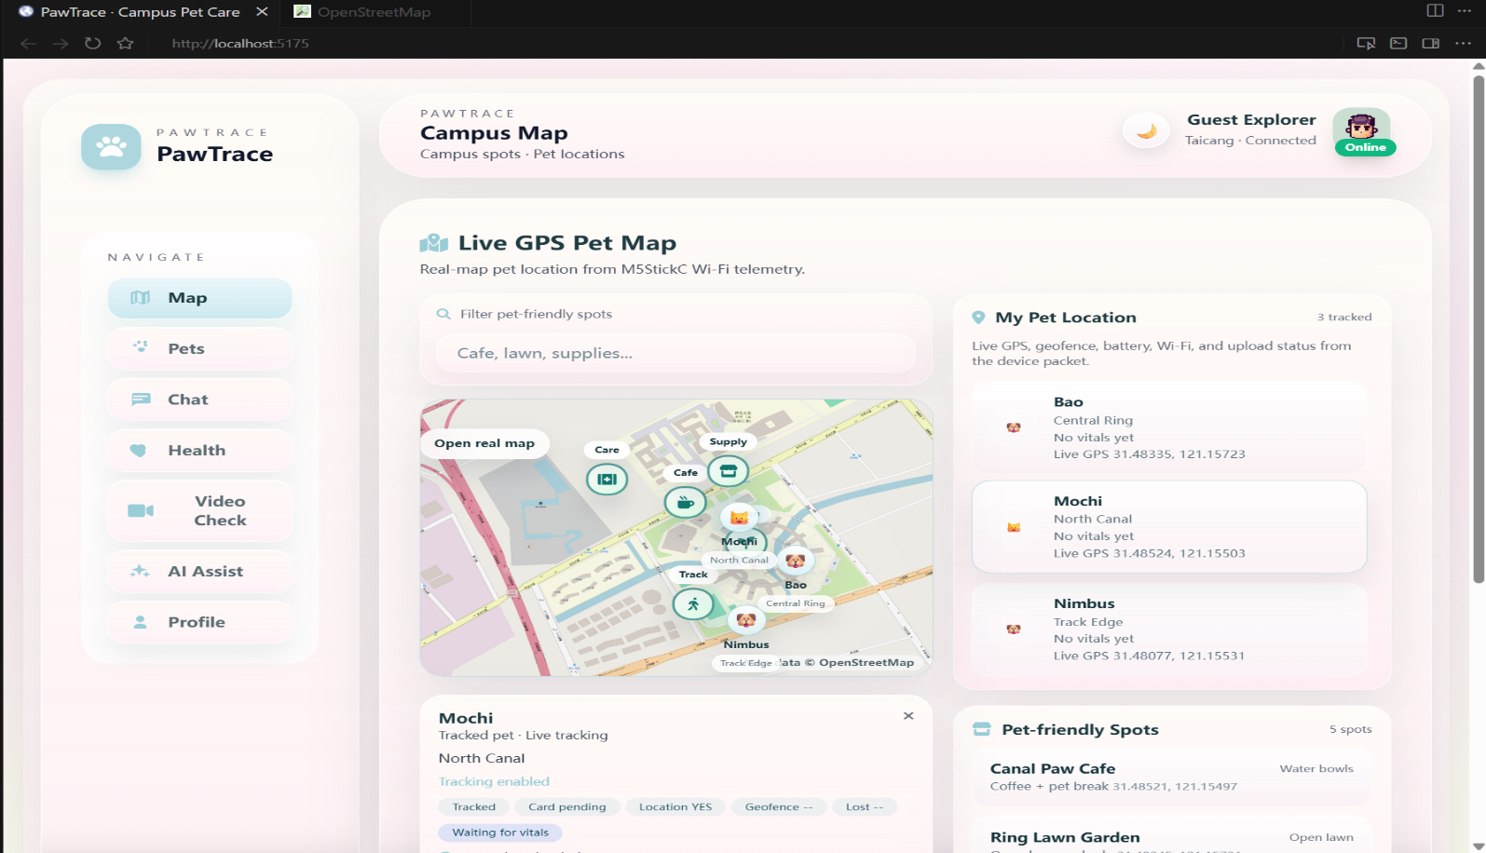
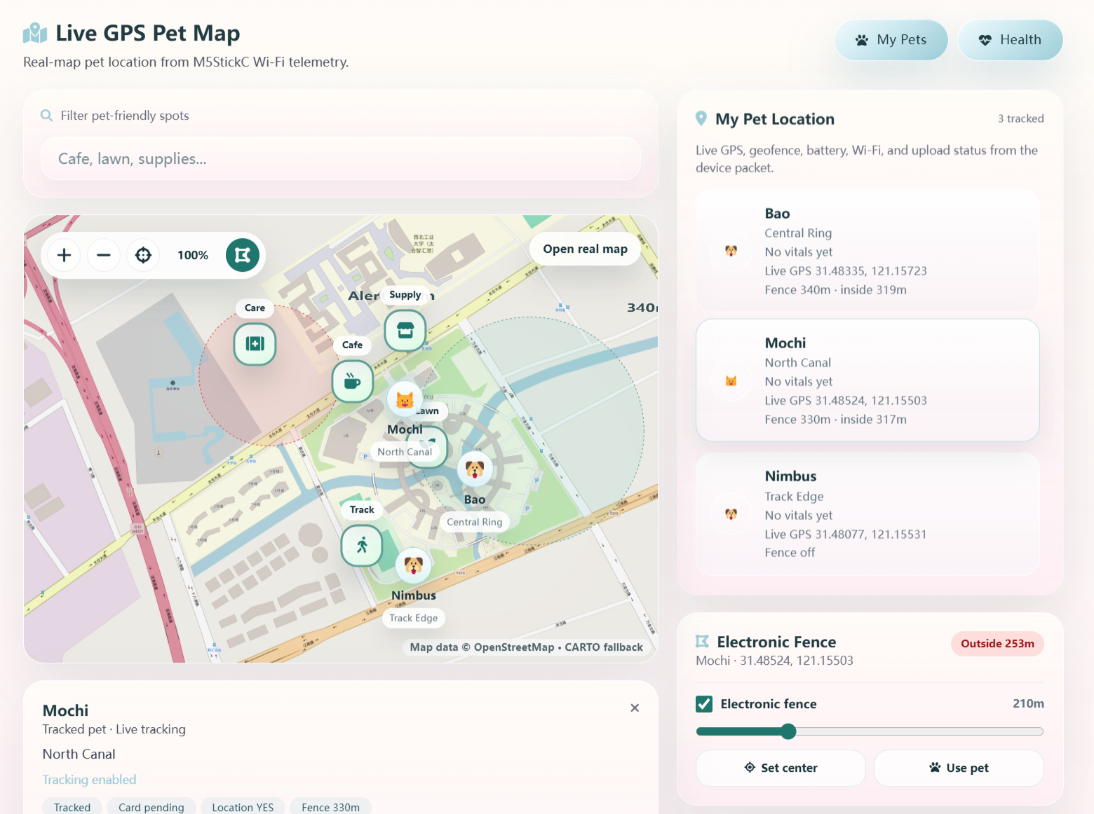
Key iteration: An Electronic Fence function was added. Users can set a fence centre and radius on the map, and the system alerts the owner when the pet leaves the safe zone.
After optimisation, the GPS function changed from passive location checking to proactive safety monitoring.
Quantitative evidence after optimization:
- Proactive alert ability: Available
- Fence setup: User can set centre and radius
- Safety value: Proactive safety monitoring
- Usefulness rating target: ≥4/5
This iteration made Pawtrace more useful for preventing pet loss, rather than only responding after the pet was already missing.

